B. Tech. PROJECT REPORT (Mid-Semester Evaluation)

EXPLAINABLE DEEP LEARNING FRAMEWORK FOR AUTOMATED ECG ARRHYTHMIA DETECTION AND CLASSIFICATION

Submitted by:

SIDHESH MAHESH TAVARE (2314037)
NIKHIL KUMAR SINGH (2314055)

Under the Guidance of:
DR. ARNAB NANDI



DEPARTMENT OF ELECTRONICS AND COMMUNICATION ENGINEERING

NATIONAL INSTITUTE OF TECHNOLOGY SILCHAR, ASSAM (INDIA)-788010

Abstract
Deep learning models for automated electrocardiogram (ECG) arrhythmia classification frequently report accuracies above 98%, yet published evidence shows that these figures fall considerably when models are evaluated on patients not seen during training, on external databases, or on noisy signals, and that the explanations attached to such models are rarely validated against clinical ECG knowledge [1], [2], [3]. This project aims to develop an explainable deep learning framework for automated ECG arrhythmia detection and classification that addresses these issues together.
The project has three objectives:
- To develop a hybrid deep learning classifier evaluated under a strict inter-patient protocol on the MIT-BIH Arrhythmia Database with external testing on a second database
- To apply and evaluate explainable AI (XAI) methods, such as SHAP and Grad-CAM, by measuring the consistency of explanations and their agreement with recognised ECG features
- To assess how classification performance and explanation stability degrade under realistic noise from the MIT-BIH Noise Stress Test Database, using uncertainty estimates to flag unreliable predictions.
The expected outcomes are a patient-independent arrhythmia classifier with per-class and macro-averaged results, a quantitative evaluation of explanation quality, and a robustness analysis of both predictions and explanations under noise.
Up to the mid-semester evaluation, a working training, evaluation and Grad-CAM pipeline has been built and tested on the pre-segmented MIT-BIH heartbeat dataset of Kachuee et al. [35] (five AAMI classes, intra-patient split). A baseline 1D CNN reached 94.41% accuracy but only 76.29% macro F1, because of very low precision on the rare Fusion (26.0%) and supraventricular (55.9%) classes. Of five step-by-step changes, selecting the epoch on validation macro F1, square-root class weights and a residual network gave the largest gains, and the final model reached 98.41% accuracy and 91.10% macro F1 on the same 21,892-beat test set, with Grad-CAM heatmaps for every class. These intra-patient results are treated as a development baseline for the patient-independent framework.

Introduction
Background and Motivation
The ECG is a widely used non-invasive tool for detecting cardiac arrhythmias, and deep learning is now widely applied to automate its interpretation: CNNs are used in 58.7% of 368 studies reviewed by Xiao et al. [1] and in 62% of 119 studies reviewed by Kulkarni et al. [2], with hybrid CNN-recurrent and Transformer-based models increasingly common [1], [2].
Significance of the Problem
Three issues limit the clinical usefulness of current models. First, reported performance depends heavily on the evaluation protocol: F1 fell from 95.52% under intra-patient evaluation to 83.89% under inter-patient evaluation [1], and only 30.3% of 122 reviewed articles followed the inter-patient paradigm [4]. Second, deep models are often black boxes, and fewer than 10% of studies validated explanation maps against clinically meaningful ECG structures [2]. Third, robustness to realistic noise is tested narrowly, often with additive white Gaussian noise only [5].
Problem Statement
There is a need for an ECG arrhythmia classification framework whose performance is measured on unseen patients, whose explanations are checked for consistency and clinical plausibility, and whose predictions and explanations are evaluated for robustness under realistic noise.
Objectives
• Objective 1 – Patient-independent baseline: a hybrid deep learning classifier evaluated under a strict inter-patient protocol (MIT-BIH DS1/DS2) with external testing on a second database, reporting per-class and macro F1 alongside accuracy.
• Objective 2 – Validated explanations: apply post-hoc XAI methods (e.g. SHAP and Grad-CAM) and measure the within-class consistency of explanations and their agreement with ECG features (P wave, QRS complex, RR interval).
• Objective 3 – Robustness of predictions and explanations: assess how performance and explanation stability degrade under NSTDB noise (baseline wander, muscle artefact, electrode motion) at graded SNRs, using uncertainty estimates to flag unreliable predictions.

Literature Review
A literature survey of 36 papers (5 reviews and 31 original studies) on deep learning and explainable AI for ECG arrhythmia classification was carried out. The findings are grouped into four themes below.
Architectures
CNNs remain the dominant architecture [6], [7], [1], [2], but hybrid designs pairing a convolutional front end with a recurrent or attention module are increasingly common, including CNN-LSTM [8], [9], [10], CNN-BiLSTM [11], [12], multi-scale CNN-BiLSTM [13] and dual-branch BiLSTM/capsule fusion [5]. Transformers are the newest development [14], [15], [16], [17], [18], with a gain of 0.845% over 1D-CNNs at increased cost [2], while lightweight designs remain competitive [8], [19]; graph networks [20] and handcrafted features with XGBoost [21] offer alternatives.
Explainable AI Methods
SHAP is the most widely used explanation method [8], [3], [21], [22], [23], [24], [19], followed by Grad-CAM [25], [18] and class activation maps [17]; generative counterfactual ECGs captured rhythm irregularity that saliency maps missed [26]. Some report clinically plausible explanations (absent P waves, wide QRS complexes, PR interval) [8], [19], [21]. However, Beck and John found that explanations for APB and PVC beats were inconsistent within a class and not validated by medical professionals, and removed the LSTM from their model because it hampered the XAI methods [3]. Fewer than 10% of studies validated explanation maps against clinically meaningful ECG structures [2].
Datasets and Evaluation
The MIT-BIH Arrhythmia Database dominates the field, used in 61% [1] and 78.7% [4] of reviewed studies, while PTB-XL is the main 12-lead benchmark [18], [27], [19], [28]. Evaluation protocol strongly affects results: F1 fell from 95.52% (intra-patient) to 83.89% (inter-patient) [1], and one study reported 99.00% accuracy on a beat-wise split but 91.69% on a patient-wise split, with Fusion recall of only 0.021 [11]. External validation was performed in only 18.5% of studies, with a mean accuracy drop of 8.7% [2].
Robustness
Robustness testing is uneven. Hassoon et al. tested only additive white Gaussian noise, with F1 falling to 32.46% at 5 dB [5]; [25] did not test under noise, and [15] did not verify performance on wearable signals with motion artefacts. Ashhad et al. showed that Dempster-Shafer uncertainty-aware fusion was more robust than score- or feature-level fusion under NSTDB noise from 15 to 0 dB [30]. Denoising front ends include wavelet methods [12], [13], [15], adaptive LMS filtering [31] and a denoising autoencoder [32]. Rejecting high-uncertainty predictions raised macro F1 from 0.6635 to 0.8688, and cardiologists attributed most high-uncertainty cases to noise [33].
Comparison of Key Studies
Among the six most relevant studies, the SHAP-based models of [8] and [3] reached 98.24% and 98.30% accuracy without a stated patient split (the latter only 73.45% on combined data). Inter-patient studies [29], [5] reported AFib F1 of 77.9% and 99.55% accuracy, the latter falling to 32.46% F1 at 5 dB AWGN; [11] gave 99.00% beat-wise versus 91.69% patient-wise accuracy, and [30] reached 98.8% and was robust to 15–0 dB noise, mostly without XAI.
Research Gaps
• Gap 1 – Explanations are rarely validated and often inconsistent: SHAP and Grad-CAM are widely applied [8], [21], [22], [25], [24], but fewer than 10% of studies validated them against clinical ECG structures [2], and explanations were inconsistent within a class [3].
• Gap 2 – Explainability is seldom combined with patient-independent evaluation: several XAI studies do not describe patient separation [8], [3], [22], [25], while strong inter-patient studies often include no XAI [29], [11], [12].
• Gap 3 – Robustness to realistic noise is tested narrowly and is not linked to explanations: noise tests are limited to AWGN [5] or Gaussian noise [13], or are absent [25], [15], and none of the surveyed papers tests whether explanations remain stable under noise [30], [32], [33].
• Gap 4 – Minority classes and external generalisation remain weak: patient-wise Fusion and S recall were only 0.021 and 0.209 [11], the F and S classes remain hardest [14], [9], [34], [15], and only 18.5% of studies validate externally [2].

Methodology / Proposed Work
The proposed framework follows directly from the three objectives and is summarised in Figure 1.
Block Diagram
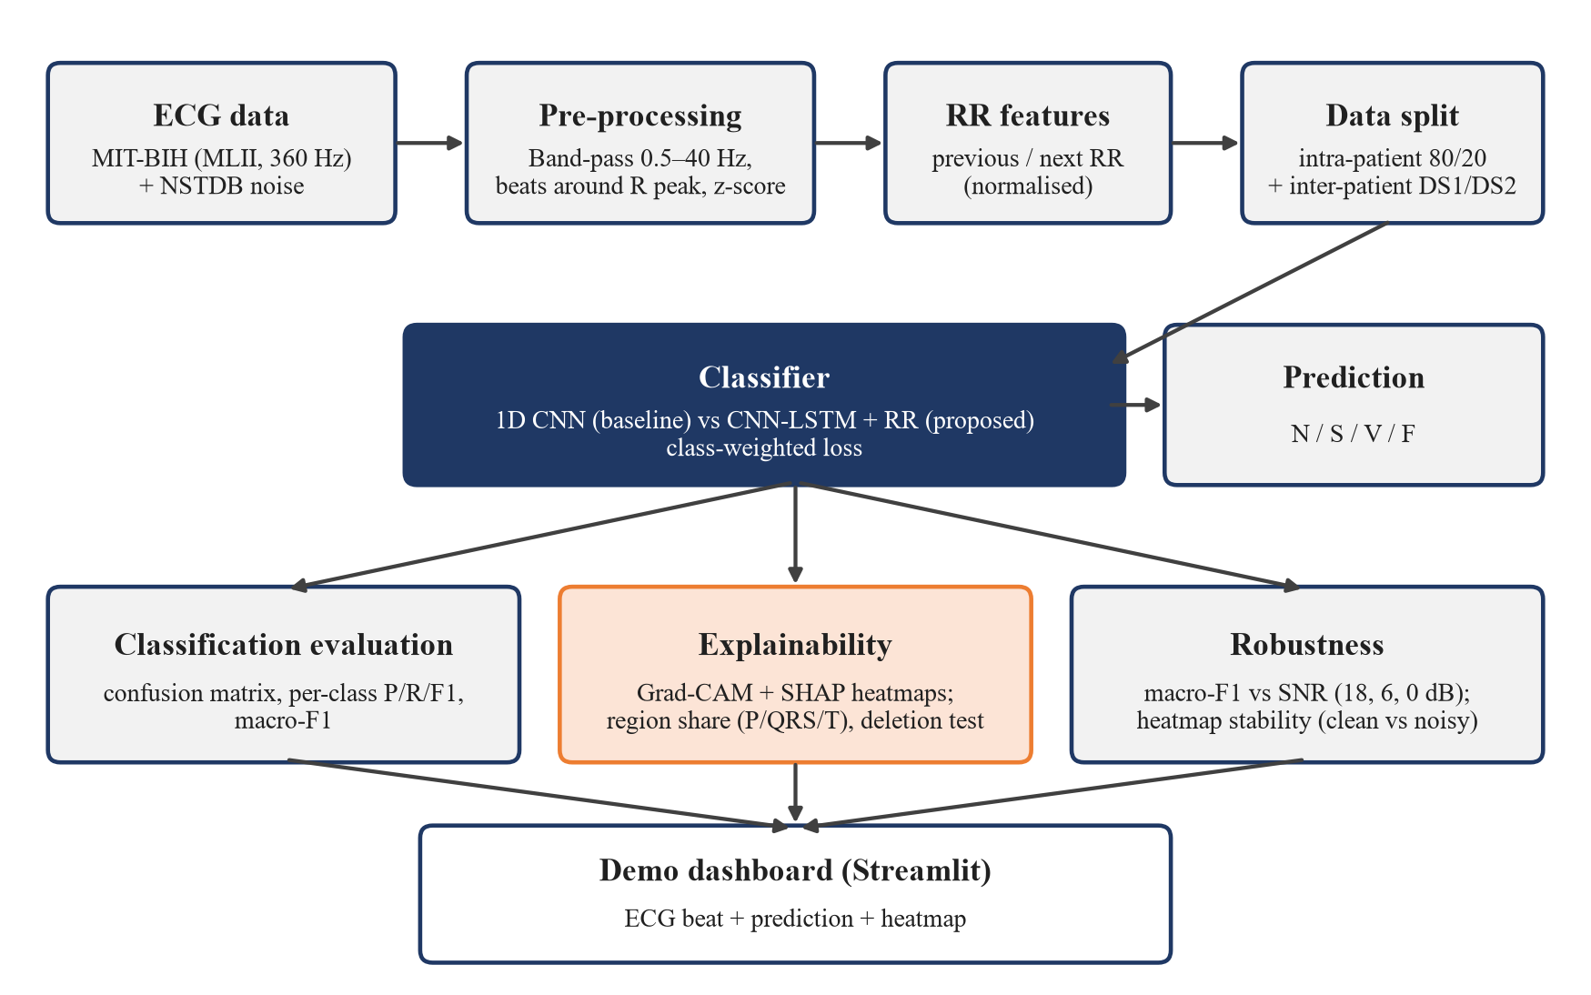
Figure 1: Block diagram of the proposed framework
Datasets
The MIT-BIH Arrhythmia Database with AAMI classes N, S, V, F, Q and the inter-patient DS1/DS2 split is used for Objective 1. An external database such as INCART or PTB-XL [5], [12], [19], [15] will be used for cross-database testing; INCART is preferred because, like MIT-BIH, it provides beat-level annotations (a stretch goal, otherwise future work). The MIT-BIH Noise Stress Test Database (baseline wander, muscle artefact, electrode motion) is used for the robustness tests of Objective 3, as in [30].
Classification Model
A hybrid model combining a convolutional front end with a recurrent or attention module is used [2]. The baseline is a 1D CNN with three convolutional blocks (32, 64 and 128 filters, kernel sizes 7, 5 and 3, each with batch normalisation, ReLU and max-pooling), global average pooling, a 64-unit dense layer and a softmax output (about 44,700 parameters), already implemented. The proposed model adds an LSTM layer with 64 units whose last hidden state is concatenated with the previous and next RR intervals (each divided by the record's mean RR) before a 64-unit dense layer and a softmax over N, S, V and F; a residual CNN, which gave the best preliminary results, is kept as a comparison model.
Class imbalance is handled with class-weighted cross-entropy on the training partition only. Fully balanced weights (F:N ratio 113:1) caused many false Fusion predictions, while square-root-balanced weights (10.6:1) gave the best results. Training uses Adam, batch size 128 and at most 30 epochs, with the best epoch chosen on validation macro F1 rather than validation loss (this alone raised test macro F1 from 76.29% to 83.96%); the learning rate will be tuned on the validation set.
Explainability
Grad-CAM [37], already implemented, and Gradient SHAP [38] will be applied, and explanations evaluated for within-class consistency and agreement with the P wave, QRS complex and RR interval using three measures: (i) region share, the share of absolute attribution in fixed windows around the R peak (P wave [−250, −80] ms, QRS [−50, +50] ms, T wave [+100, +400] ms), averaged per class; (ii) a deletion test, in which the 10% highest-attribution samples are set to zero and the drop in predicted-class probability is compared with removing 10% at random; and (iii) stability, the Pearson correlation between the attribution maps of a clean and a noisy version of the same beat.
Robustness and Uncertainty
The NSTDB muscle-artefact ('ma') record will be scaled and added to the test beats at SNR = 18, 6 and 0 dB, where SNR = 10·log10(P_signal / P_noise), and macro F1 and explanation stability will be plotted against SNR for both models. Monte Carlo dropout, as in [33], is the planned uncertainty method for flagging unreliable predictions if time permits; otherwise it is listed as future work.
Evaluation Metrics
Accuracy, per-class precision, recall and F1, and macro F1 will be reported, since overall accuracy alone can hide poor minority-class performance [1].
Tools
Python 3 with TensorFlow 2.20 / Keras, NumPy, pandas, scikit-learn, Matplotlib, seaborn, wfdb, the SHAP library and Streamlit, run on Kaggle notebooks with an NVIDIA Tesla T4 GPU.

Work Done Till Mid-Semester
The work so far covers the literature survey, the framework design and two rounds of preliminary experiments, V1 (baseline) and V2 (step-by-step improvements).
Completed Tasks
The literature survey and research gaps; the framework design (AAMI class mapping, intra- and inter-patient protocols, explanation metrics and noise settings); V1, a class-weighted baseline 1D CNN with full test-set evaluation and Grad-CAM for each class; and V2, five controlled experiments (E1–E5) with validation-based threshold tuning, raising test macro F1 from 76.29% to 91.10%, followed by Grad-CAM on the final model.
Dataset Used in the Preliminary Experiments
The preliminary experiments use the pre-segmented MIT-BIH heartbeat dataset of Kachuee et al. [35]. Each beat is 187 samples long (1.5 s at 125 Hz), scaled to [0, 1], zero-padded and labelled with one of five AAMI classes. The provided training file (87,554 beats) was split 80/20 with stratification (seed 42) into training (70,043) and validation (17,511) sets, and the provided test file (21,892 beats) was used only for final evaluation. The data are strongly imbalanced: in both files N makes up about 82.8% of beats, Q 7.35%, V 6.61%, S 2.54% and F only 0.73%, so a model that always predicts N would exceed 80% accuracy and macro F1 is the main metric. Because the split is by beat, all preliminary results are intra-patient. Every beat starts at its R peak and contains a second large peak later in the window, most likely the next R peak (Figure 2).
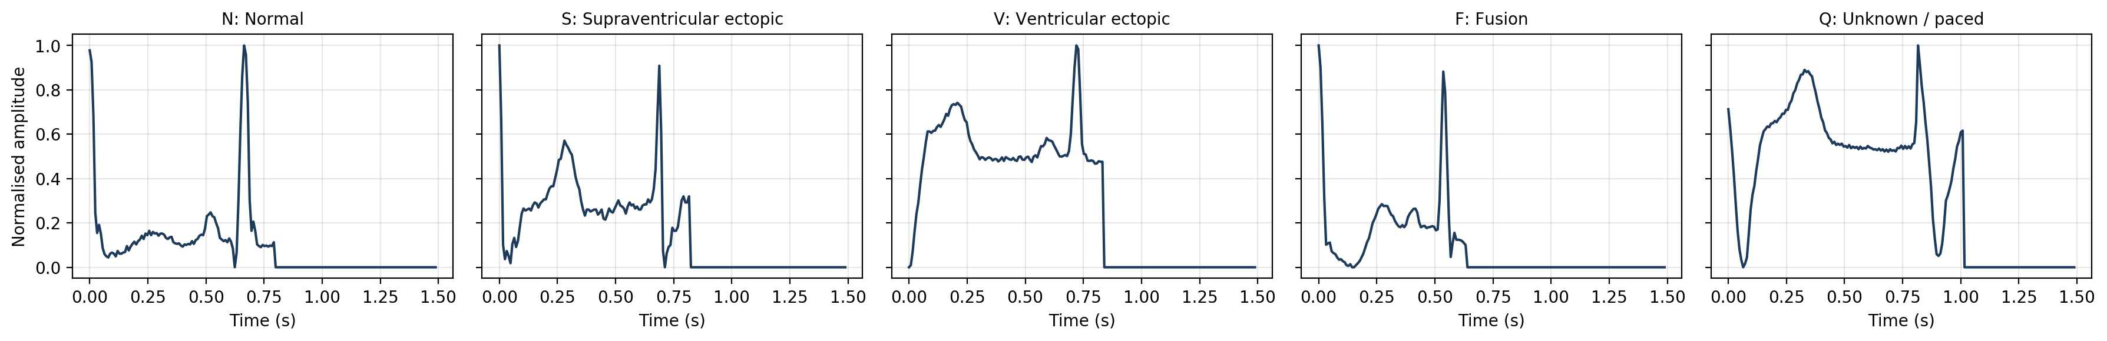
Figure 2: One example beat of each class (187 samples, 125 Hz, zero-padded)
V1: Baseline 1D CNN
The baseline 1D CNN (44,741 parameters, five-class output) was trained with Adam (learning rate 10⁻³), batch size 128 and fully balanced class weights (N 0.24, S 7.88, V 3.03, F 27.31, Q 2.72; F:N ≈ 113:1), with early stopping on validation loss (patience 6); training stopped after 17 epochs and the weights of epoch 11 were restored. It reached 94.41% accuracy but only 76.29% macro F1. F1 was 97.0% for N and Q and 86.6% for V, but only 60.9% for S and 40.0% for F. Class weighting gave high recall on the rare classes (F recall 86.4%) at the cost of precision: of the 538 beats predicted as F only 140 were truly F (293 were N), giving an F precision of 26.0%, and S precision was 55.9%. The largest S error was S → N (163 of 556 S beats, 29%).
Training was also unstable: training loss fell smoothly from 0.706 to 0.175, but validation accuracy jumped between 14.5% and 95.1% from one epoch to the next and validation loss ranged from 0.349 (epoch 11) to 4.29 (epoch 2). This gap between training and inference behaviour, rather than overfitting, is what V2 set out to fix.
V2: Step-by-step Improvements
Each V2 experiment keeps the same split and seed and adds one change to the previous experiment; the test set was never used to choose an epoch, model or threshold. E1 chooses the best epoch by validation macro F1; E2 adds a lower learning rate (5×10⁻⁴), gradient clipping (norm 1.0) and batch-normalisation momentum 0.9; E3 uses square-root class weights (F:N 10.6:1); E4 adds light augmentation (amplitude scaling ±10%, Gaussian noise σ = 0.01, time shift ±3 samples); and E5 replaces the CNN with a residual CNN [36] with three residual blocks (185,477 parameters). Finally, per-class probability scale factors were tuned on the validation set for E5, the experiment with the highest validation macro F1 (93.19%).
Choosing the epoch on validation macro F1 (E1) raised test accuracy to 96.28% and macro F1 to 83.96%, with F F1 rising from 40.00% to 68.12%. The stability settings of E2 lowered macro F1 to 78.30% (S F1 49.13%). Square-root weights (E3) gave 97.39% accuracy and 87.58% macro F1, with F precision rising to 75.60%. Augmentation (E4) lowered macro F1 slightly to 86.20%, and the residual network (E5) gave 98.29% accuracy and 90.77% macro F1, with S and F F1 of 81.22% and 78.53% (Figure 3). E5 also trained most smoothly, while E2–E4 reached the 30-epoch cap and may be slightly under-trained; all five experiments took 8.1 minutes on a Tesla T4 GPU.
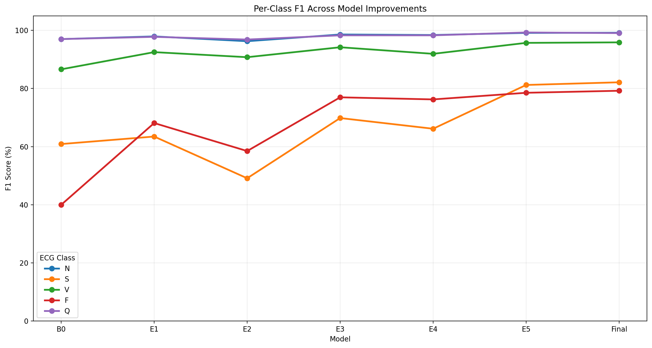
Figure 3: Per-class F1 across the V2 experiments
The largest gains came from selecting the epoch on validation macro F1 (E1, +7.67 macro F1), square-root class weights (E3, +9.28 over E2) and the residual network (E5, +4.57 over E4). The E2 stability settings (−5.66) and augmentation (E4, −1.38) did not help on their own, and threshold tuning added only 0.33 points, trading some S and F recall for precision.
Final Model Results
The final model is E5 with tuned scale factors of N = 3.0 and 1.0 for every other class, so the model must be more confident before predicting a non-N class. On the test set it reached 98.41% accuracy, 91.10% macro F1 and 98.37% weighted F1 (macro precision / recall 93.26% / 89.12%). Precision / recall were 98.74% / 99.62% for N, 87.58% / 77.34% for S, 98.05% / 93.78% for V, 82.12% / 76.54% for F and 99.81% / 98.32% for Q, giving F1 scores of 99.18%, 82.14%, 95.87%, 79.23% and 99.06% respectively (Figure 4).
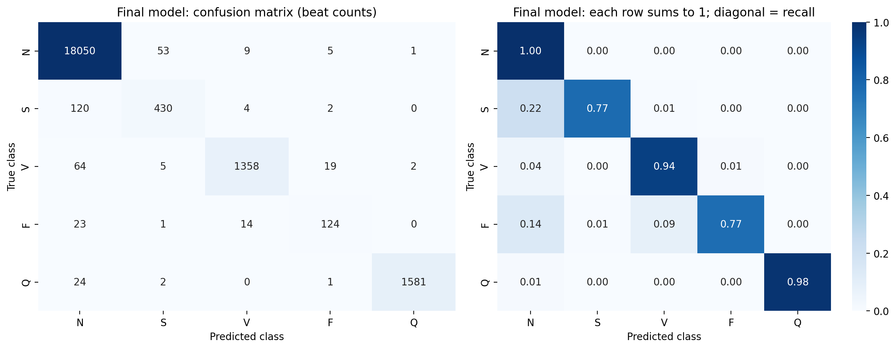
Figure 4: Confusion matrix of the final model
Compared with the baseline on the same 21,892-beat test set, accuracy rose by 4.00 points (94.41% → 98.41%) and macro F1 by 14.81 points (76.29% → 91.10%), and F1 improved for every class (S 60.9 → 82.1, V 86.6 → 95.9, F 40.0 → 79.2). False Fusion predictions fell from 398 to 27 and false S predictions from 294 to 61, raising F precision from 26.02% to 82.12% and S precision from 55.86% to 87.58%. Fusion recall is lower than the baseline's (76.5% vs 86.4%), because the baseline's high recall came from over-predicting F. The largest remaining error is S → N (120 of 556 S beats, 22%, down from 163); S beats differ from N beats mainly in timing, which supports adding explicit RR-interval features in the proposed model.
Grad-CAM Explanations
Grad-CAM [37] was applied to the last convolutional layer of each model, explaining the most confidently and correctly classified test beat of each class (Figure 5 for the final model).
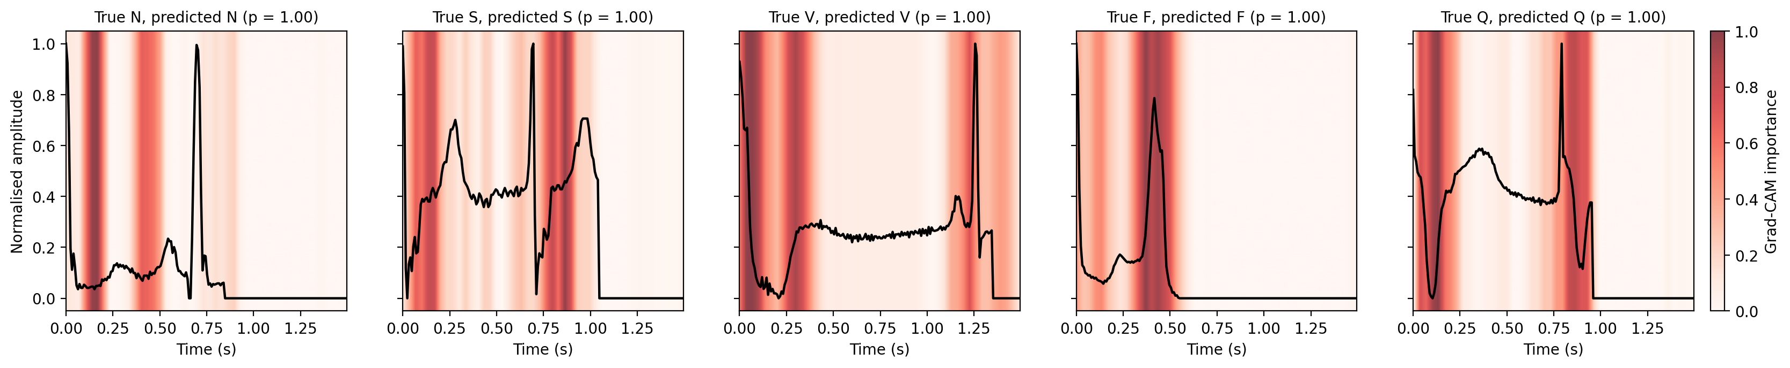
Figure 5: Grad-CAM heatmaps of the V2 final model, one beat per class
Both models concentrate on a few narrow regions. The baseline focuses mostly on the start of the window and on the second large peak or the end of the signal. The final model's maps are broader and more often cover waveform features: for N beats at 0.12–0.2 s and 0.4–0.5 s, before the second R peak (a P-wave-like bump), and for F beats a strong broad band at 0.3–0.5 s centred on the second peak. Since each window starts at the current R peak, the second peak is likely the next R peak, suggesting the models partly use the timing of the next beat (an implicit RR cue) as well as beat shape. These observations are qualitative (heat at the first samples may partly be a padding edge effect) and will be tested with the region-share and deletion measures.
Challenges Faced
• Severe class imbalance: fully balanced weights made the baseline over-predict the rare classes (F precision 26.0%); square-root weights fixed most of this.
• Unstable training: validation accuracy swung between 14.5% and 95.1%, so early stopping on validation loss stopped too early; epoch selection on validation macro F1 and the residual network gave smoother results.
• Not every planned improvement helped: E2 and E4 lowered macro F1, and because the experiments were cumulative, the best combination of changes is not yet known.
• The preliminary data are pre-processed, intra-patient and include the Q class, so results are optimistic and not directly comparable with the planned four-class, inter-patient results; each experiment was run once with one seed.

Work Plan for Next Phase
The following tasks build on the pipeline developed so far.
• Port the pipeline from the pre-segmented Kaggle beats to the raw MIT-BIH dataset
• Implement pre-processing and the inter-patient DS1/DS2 split of the MIT-BIH database.
• Implement and train the hybrid classifier; report per-class and macro F1; test on the external database.
• Apply XAI methods and evaluate explanation consistency.
• Generate NSTDB noise at graded SNRs; evaluate classification, explanation stability and uncertainty.
• Analyse results, prepare the final report and presentation.

Expected Outcomes
Deliverables
• A patient-independent ECG arrhythmia classifier with per-class and macro-averaged results under an inter-patient protocol and on an external database.
• A quantitative evaluation of explanation with two XAI methods.
• A robustness and uncertainty analysis of both predictions and explanations under realistic NSTDB noise.
• Final report and presentation.
Expected Results
On the intra-patient split, macro F1 of about 90% is expected, in line with the 91.10% already reached. On the inter-patient DS1/DS2 split, performance is expected to be clearly lower [1], [11], with S and F remaining the hardest classes; the RR features are expected to improve S recall in particular. V beats are expected to place a larger share of importance on the QRS region than N beats, and deleting the most important samples should lower confidence much more than deleting random samples. Under NSTDB noise, macro F1 and explanation stability are expected to fall as the SNR decreases from 18 dB to 0 dB.

References
[1] Q. Xiao, K. Lee, S. A. Mokhtar, I. Ismail, A. L. bin Md Pauzi, Q. Zhang, and P. Y. Lim, "Deep learning-based ECG arrhythmia classification: A systematic review," Applied Sciences, vol. 13, Art. no. 4964, 2023.
[2] N. N. Kulkarni, Nagaraja G. S., B. G. Sudarshan, and Yeriswamy M. C., "Recent advances in deep learning based arrhythmia classification using ECG and PPG signals: A systematic review," Discover Computing, vol. 29, Art. no. 666, 2026.
[3] J. Beck and A. John, "Explainable AI (XAI) for arrhythmia detection from electrocardiograms," arXiv:2508.17294, 2025.
[4] G. A. L. Silva, P. H. L. Silva, G. J. P. Moreira, V. L. S. Freitas, J. C. Gertrudes, and E. J. S. Luz, "A systematic review of ECG arrhythmia classification: Adherence to standards, fair evaluation, and embedded feasibility," arXiv:2503.07276, 2025.
[5] B. A. Hassoon, S. Xiong, M. A. Hasson, R. Salahudeen, A. O. Abdulsalami, and T. Khan, "Dual-branch bidirectional attention fusion of temporal and hierarchical representations for robust ECG arrhythmia classification," Expert Systems with Applications, vol. 331, Art. no. 133409, 2026.
[6] Z. Ebrahimi, M. Loni, M. Daneshtalab, and A. Gharehbaghi, "A review on deep learning methods for ECG arrhythmia classification," Expert Systems with Applications: X, vol. 7, Art. no. 100033, 2020.
[7] Y. Ansari, O. Mourad, K. Qaraqe, and E. Serpedin, "Deep learning for ECG arrhythmia detection and classification: An overview of progress for period 2017–2023," Frontiers in Physiology, vol. 14, Art. no. 1246746, 2023.
[8] N. Alamatsaz, L. Tabatabaei, M. Yazdchi, H. Payan, N. Alamatsaz, and F. Nasimi, "A lightweight hybrid CNN-LSTM explainable model for ECG-based arrhythmia detection," Biomedical Signal Processing and Control, vol. 90, Art. no. 105884, 2024.
[9] P. Pramkeaw, W. Leangruttananon, P. Suksomboon, T. Tapianthong, and S. Kitdanarakorn, "Deep learning-based ECG arrhythmia detection system: A comparative study of CNN, RNN, and LSTM architectures," in Proc. 2026 IEEE Int. Conf. Cybernetics and Innovations (ICCI), 2026, doi: 10.1109/ICCI68752.2026.11506504.
[10] Y. Wang and S. Rani, "Hybrid CNN-LSTM model for ECG-based arrhythmia detection in internet of medical things," Discover Internet of Things, vol. 6, Art. no. 7, 2026.
[11] Sa. I. Ibrahim, "A hybrid deep learning algorithm for ECG-based heart disease classification," Scientific Reports, vol. 16, Art. no. 29911, 2026.
[12] S. Qin, L. Han, X. Zhang, Y. Zhang, and N. Li, "ECG beat classification based on dilated multi-scale ResNet and BiLSTM," Measurement Science and Technology, vol. 37, Art. no. 285701, 2026.
[13] K. K. Reddy C., A. Daduvy, V. S. Kaza, M. Shuaib, M. Mohzary, S. Alam, and A. Sheneamer, "A multi-scale convolutional LSTM-dense network for robust cardiac arrhythmia classification from ECG signals," Computers in Biology and Medicine, vol. 191, Art. no. 110121, 2025.
[14] H. El-Ghaish and E. Eldele, "ECGTransForm: Empowering adaptive ECG arrhythmia classification framework with bidirectional transformer," Biomedical Signal Processing and Control, vol. 89, Art. no. 105714, 2024.
[15] S. Huang, S. Chen, Z. Guo, K. Ji, and M. Zhang, "MSCA-TNet based deep learning method for ECG arrhythmia classification," Scientific Reports, vol. 16, Art. no. 28152, 2026, doi: 10.1038/s41598-026-58850-y.
[16] H. Liu, "A hybrid model combining 1D-CNN and BERT for intelligent ECG arrhythmia classification," Scientific Reports, vol. 15, Art. no. 44456, 2025.
[17] D. Kim, K. R. Lee, D. S. Lim, K. H. Lee, J. S. Lee, D.-Y. Kim, and C.-B. Sohn, "A novel hybrid CNN-transformer model for arrhythmia detection without R-peak identification using stockwell transform," Scientific Reports, vol. 15, Art. no. 7817, 2025.
[18] Q. Chen, C. Lian, B. Xu, Q. Zhou, Y. Su, and Z. Zeng, "Large language model-assisted multi-scale hierarchical classification of ECG signals," Knowledge-Based Systems, vol. 324, Art. no. 113807, 2025.
[19] A. Anand, T. Kadian, M. K. Shetty, and A. Gupta, "Explainable AI decision model for ECG data of cardiac disorders," Biomedical Signal Processing and Control, vol. 75, Art. no. 103584, 2022.
[20] M. Lee, J. Lim, and J. Kim, "ECG-GraphNet: Advanced arrhythmia classification based on graph convolutional networks," Heart Rhythm O2, vol. 6, no. 8, pp. 1199–1211, 2025.
[21] J. J. Kolliyil and M. C. Brindise, "Automated detection of arrhythmias using a novel interpretable feature set extracted from 12-lead electrocardiogram," Computers in Biology and Medicine, vol. 189, Art. no. 109957, 2025.
[22] M. A. Talukder, A. S. Talaat, N. J. Muna, A. Alazab, M. Kazi, and U. K. Das, "An explainable deep learning framework for trustworthy arrhythmia detection from ECG signals," Scientific Reports, vol. 15, Art. no. 39496, 2025.
[23] V. Asha, P. Kavitha, R. Sri Gokulam, S. Ciyamala Kushbu, M. Jayashree, and N. Gayathri, "ECG arrhythmia classification a lightweight, explainable, and web-deployable deep learning framework using knowledge-distilled GAN features and Flask," Natural Resources for Human Health, vol. 6, no. 14s, pp. 289–296, 2026.
[24] P. Kavitha and L. Shakkeera, "An explainable deep learning framework for accurate and automated cardiac arrhythmia classification using electrocardiogram signals," Biomedical Signal Processing and Control, vol. 117, Art. no. 109590, 2026.
[25] D. Tenepalli and T. M. Navamani, "Design of an explainable deep learning framework for ECG-based arrhythmia prediction," IEEE Access, vol. 13, pp. 200754–, 2025, doi: 10.1109/ACCESS.2025.3636481.
[26] J.-H. Jang, Y.-Y. Jo, S. Kang, J. M. Son, H. S. Lee, J. Kwon, and M. S. Lee, "A novel XAI framework for explainable AI-ECG using generative counterfactual XAI (GCX)," Scientific Reports, vol. 15, Art. no. 23608, 2025.
[27] S. Smigiel, K. Palczynski, and D. Ledzinski, "ECG signal classification using deep learning techniques based on the PTB-XL dataset," Entropy, vol. 23, Art. no. 1121, 2021.
[28] N. A. Mehdi and A. A. Drigh, "ECG classification on PTB-XL: A data-centric approach with simplified CNN-VAE," arXiv:2603.07558, 2026.
[29] Y. Jeong, J. Lee, and M. Shin, "Enhancing inter-patient performance for arrhythmia classification with adversarial learning using beat-score maps," Applied Sciences, vol. 14, Art. no. 7227, 2024.
[30] M. Ashhad, S. Rahmani, M. Fayiz, A. Etemad, and J. Hashemi, "Uncertainty-aware multi-view arrhythmia classification from ECG," arXiv:2506.06342, 2025 (published at IJCNN 2024).
[31] R. S. Pashikanti, A. A. Shinde, and C. Y. Patil, "Adaptive predictive control-based noise cancellation with deep learning for arrhythmia classification from ECG signals," in Proc. 2022 Int. Conf. Intelligent Innovations in Engineering and Technology (ICIIET), 2022, doi: 10.1109/ICIIET55458.2022.9967602.
[32] J. P. Maurya, M. Manoria, and S. Joshi, "A proposed deep learning model for multichannel ECG noise reduction," Discover Artificial Intelligence, vol. 5, Art. no. 65, 2025, doi: 10.1007/s44163-025-00292-y.
[33] W. Zhang, X. Di, G. Wei, S. Geng, Z. Fu, and S. Hong, "Cardiac arrhythmia classification with rejection of ECG recordings based on uncertainty estimation from deep neural networks," Neural Computing and Applications, vol. 36, pp. 4047–4058, 2024.
[34] K. Mallikarjunamallu and S. Khasim, "Arrhythmia classification using noise filtering and 1D CNN," Traitement du Signal, vol. 41, no. 4, pp. 1847–1859, Aug. 2024.
[35] M. Kachuee, S. Fazeli, and M. Sarrafzadeh, "ECG heartbeat classification: A deep transferable representation," in Proc. IEEE Int. Conf. Healthcare Informatics (ICHI), 2018, pp. 443–444.
[36] K. He, X. Zhang, S. Ren, and J. Sun, "Deep residual learning for image recognition," in Proc. IEEE Conf. Computer Vision and Pattern Recognition (CVPR), 2016, pp. 770–778.
[37] R. R. Selvaraju, M. Cogswell, A. Das, R. Vedantam, D. Parikh, and D. Batra, "Grad-CAM: Visual explanations from deep networks via gradient-based localization," in Proc. IEEE Int. Conf. Computer Vision (ICCV), 2017, pp. 618–626.
[38] S. M. Lundberg and S.-I. Lee, "A unified approach to interpreting model predictions," in Proc. Advances in Neural Information Processing Systems (NeurIPS), 2017, pp. 4765–4774.

